Association List

1 – The Main Screen
Navigate to Association > Association List to get the Association List screen.

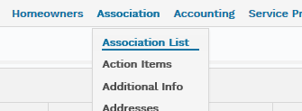
1 – Association > Association List

The initial screen will have 7 columns and the contents are ordered by Association Name.

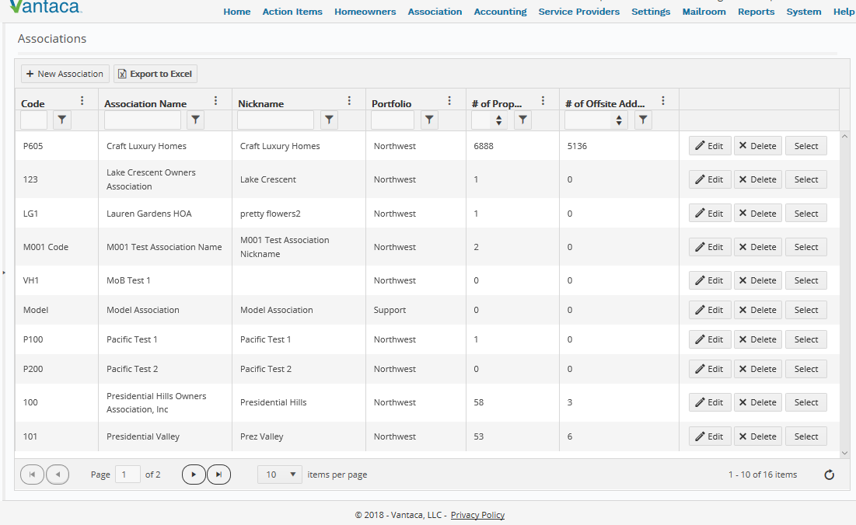
2 – Initial Association List screen

Every column header has three dots on the right side. Click on those for an alternate way of sorting or using a filter, or to select all columns that you want to see.
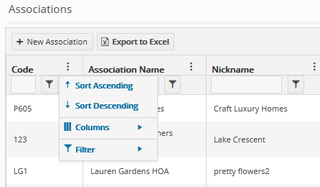
3 – Click on the three dots on the right side of a column header to get this menu

2 – Sorting on columns
The sorting can easily be changed by clicking on a column header. The first time you click, all data will be sorted by that column from 0 – 9 and then A – Z. Click again, the order will be Z – A and then 9 – 0. Click a third time and the sort will be undone. You can sort multiple columns at the same time.

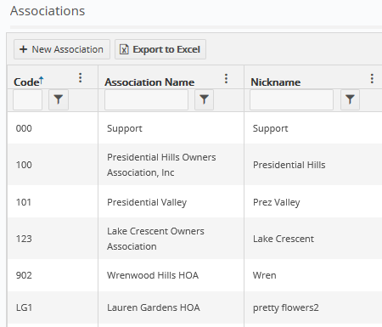
4 – Clicking once on “Code” sorted all data on that column. Notice the small blue arrow next to “Code” to indicate a sort is placed

3 – Using Filters
Every column in the Association List screen has a text box between the header and the data. This is where you can filter the data. If you type in something in one of these boxes and hit the enter key, the default filter action will be activated. What the default is, differs per column type. In this screen, generally in columns with type Text will filter on texts containing the character string you typed. Number columns will filter on “Is greater than or equal to” the number you entered.

If you want to filter in a different way, type your criteria in the box but instead of hitting Enter, click on the funnel symbol to the right of the box. This will give a list of filtering options.

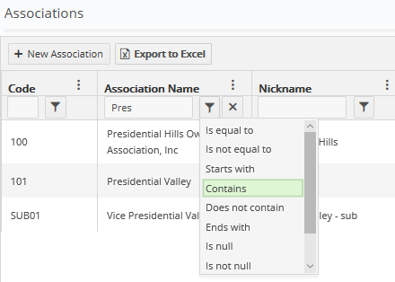
5 – Clicking on the funnel symbol opens a list of different filtering options

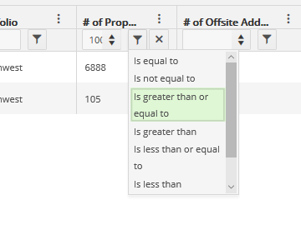
6 – It depends on the column type what kind of filtering options are available

4 – Selecting different columns
Click on the three dots on a random column header and navigate to “Columns”.

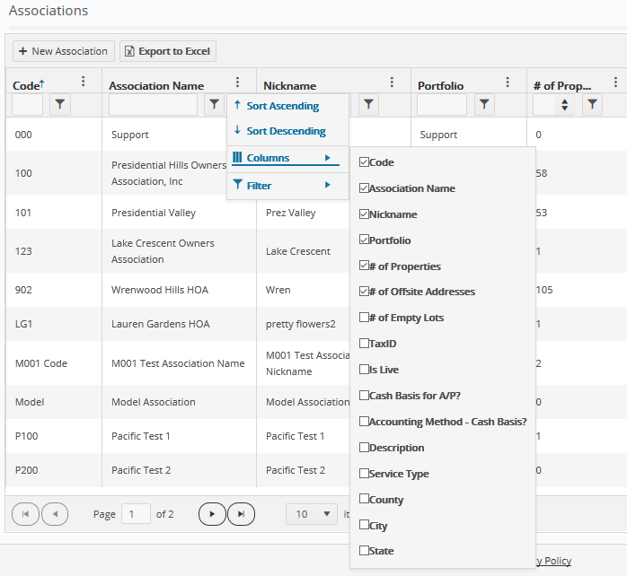
7 – Click on the three dots and hover over “Columns” to select the columns you want to see

Here you can select all the columns that you do and unselect the ones you do not want to see.

5 – Export to Excel
At any point in this screen, it is possible to export all the data into Excel by clicking on the button “Export to Excel” at the top of the screen.

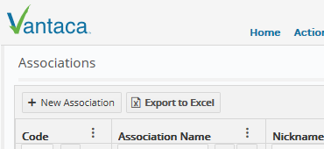
8 – Button “Export to Excel” can be used at any moment

The export will contain all the data that is currently available within the applied filters, columns and sorts.

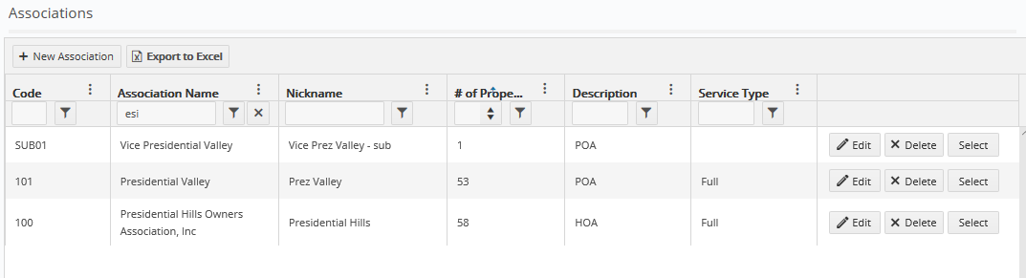
9 – Data is filtered in column 2, sorted in column 4, and the displayed columns are changed

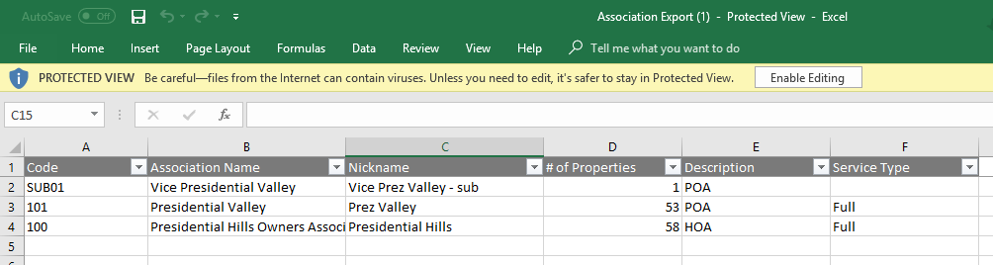
10 – After clicking “Export to Excel” in the previous screenshot, Excel will open with this data

Note that the Excel might be blocked by your browser’s settings, so make sure you allow popups for Vantaca.

6 – Buttons “Edit”, “Delete”, “Select” and “New Association”
If you have the right permissions, every record will have three buttons on the very right:

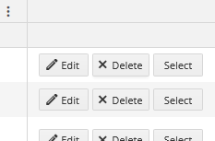
11 – With the right permissions, these three buttons will be available per association in the Association List screen

“Edit” will create a popup where you can update the basic information of that association.

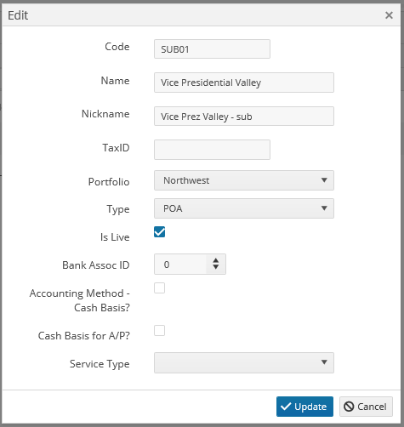
12 – Clicking on “Edit” will give this popup where the association’s basic info can be updated

“Delete” will delete the entire association. This, of course, should be handled with great care – the delete cannot be undone. For this reason, a popup appears to confirm before the association is actually deleted.

“Select” selects the association and immediately directs you to the Action Items page for that association.

On the top of the grid, to the left of the “Export to Excel” button, you can create a new association by clicking on “New Association”. This will give a similar popup as in screenshot 12 after clicking “Edit”, except it will be blank here. You can enter the basic information and set up the rest in other screens (see article “New Associations”).

